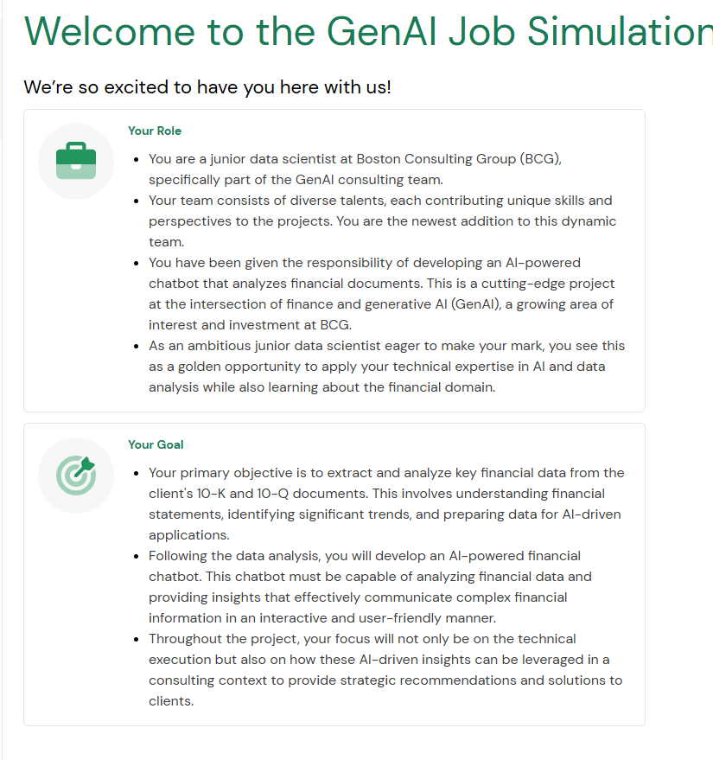

- integrating AI with financial analytics for strategic consulting solutions.
Ankit ‘s role - applying AI and data analysis skills to develop AI-powered tools, such as a financial chatbot, while learning to translate complex data into strategic business insights.
- AI-driven solution to stay ahead in the market and provide their clients with deeper, more accessible insights into corporate financial health.
- GFC's traditional methods of financial analysis, though reliable, have become time-consuming and less efficient in the face of increasing data volumes and the fast pace of financial markets. They are looking to BCG, known for its cutting-edge AI solutions, to develop a tool that can quickly analyze and interpret large sets of financial data, specifically from 10-K and 10-Q reports.

Chatbot: The project
Your role as a junior data scientist in the GenAI Consulting team is pivotal in developing an AI-powered chatbot that can analyze and provide insights on corporate financial performance from 10-K and 10-Q financial documents. This chatbot is intended to revolutionize the way GFC and its clients interact with financial data, making complex information easily accessible and understandable through conversational AI.

Key terms
- 10-K and 10-Q reports: Annual and quarterly financial reports filed by publicly traded companies containing detailed information about financial performance.
- GenAI: A branch of AI focusing on generating new content, including text and data analysis, which is crucial for the chatbot's ability to interpret and communicate financial data.
- Natural language processing (NLP): An AI technology that the chatbot will use to understand and respond to user queries in natural language.

Specific project requirements and outcomes
- Efficiency: The solution must significantly reduce the time taken to analyze financial documents compared to traditional methods.
- Accuracy: The chatbot should provide precise and reliable financial insights backed by thorough data analysis.
- User-friendly interface: The chatbot should be intuitive and easy to use for GFC’s diverse client base, regardless of their financial expertise.
- Scalability: The solution should be scalable – capable of handling an increasing number of documents and user queries.

Process Starts

What you'll do
- Extract financial data from provided 10-K documents.
- Conduct a basic analysis to identify significant financial trends and indicators.
- Format and clean the data for further processing in an AI model.

Understanding the project requirements
- Contextualizing AI in finance how AI can transform raw financial data into insightful analytics.
- Identifying key financial indicators: The ability to discern which data points or metrics are critical for financial assessment is fundamental.

Determining important factors for AI integration
- Data quality assessment: The success of AI heavily depends on the quality of data it is fed.
- Understanding data structure: AI models require data in specific formats.
This task will help you comprehend the structuring of financial data, which is a pivotal step in preparing it for AI integration.

Getting briefed:
Project context:
- Our goal is to extract meaningful insights from 10-K financial reports.
- These insights will feed into the AI chatbot, enabling it to provide in-depth financial performance analysis.
Your role and responsibilities
Data extraction:
- Research and review 10-K documents.
- Focus on key financial figures and ratios.
Basic analysis:
- Identify significant financial trends and indicators.
- Assess the financial health and performance of the companies.
Data preparation:
- Format and clean the data for AI model integration.
Deliverable:
- A comprehensive data analysis report, which should include:
  - your findings
  - a summary providing insights into the financial health of the analyzed companies.
This initial task will set the foundation for our AI model and is instrumental in moving the project forward. Your attention to detail and analytical skills will be key in this phase.

Free AI credits to explore all AI features, like doc-to-video, video generation with Veo3, and image generation with Nano Banana

Techniques for extracting key financial data from 10-Ks
They provide a detailed account of a company's financial performance, including audited financial statements, management's discussion and analysis (MD&A), and disclosures about market risk, controls, and legal proceedings.
Key sections to focus on for financial data extraction:
- Income statement: This section provides information about the company's revenue, costs, and expenses over a specific period of time.
  - Key data points: Total revenue, cost of goods sold (COGS), operating expenses, and net income.
  - Extraction technique: Look for the income statement summary, typically in the early pages of the reports. Pay attention to year-over-year changes.
- Balance sheet: This section outlines the company’s assets, liabilities, and the shareholders’ equity at a specific point in time.
  - Key data points: Current assets, long-term assets, current liabilities, long-term liabilities, and total shareholders’ equity.
  - Extraction technique: Focus on the balance sheet summary. Compare assets against liabilities to understand the company’s financial health and note any large changes in assets or liabilities.
- Cash flow statement: This shows how changes to the balance sheet and income impact cash and cash equivalents.
  - Key data points: Cash from operating activities, investing activities, and financing activities.
  - Extraction technique: Analyze the cash flow statement to understand how the company generates and spends its cash. This can provide insights into a company's liquidity.

Effective techniques for data extraction:
- Manual extraction: Start by manually reviewing the documents to understand their layout and where key information is typically found.
- Highlight and annotate: Use digital tools to highlight and annotate key figures and notes for easy reference.
- Excel and spreadsheet tools: For quantitative data, using Excel or similar spreadsheet tools can be effective. You can input key figures into a spreadsheet for analysis and comparison.
- Automated extraction tools: For more advanced users, tools such as Python (in particular, libraries such as Beautiful Soup or Pandas) can automate the extraction of data from these documents, especially if they are available in digital formats.

By understanding the structure of 10-K reports and mastering these extraction techniques, you can efficiently gather the necessary financial data for analysis and further application in AI-driven tools.
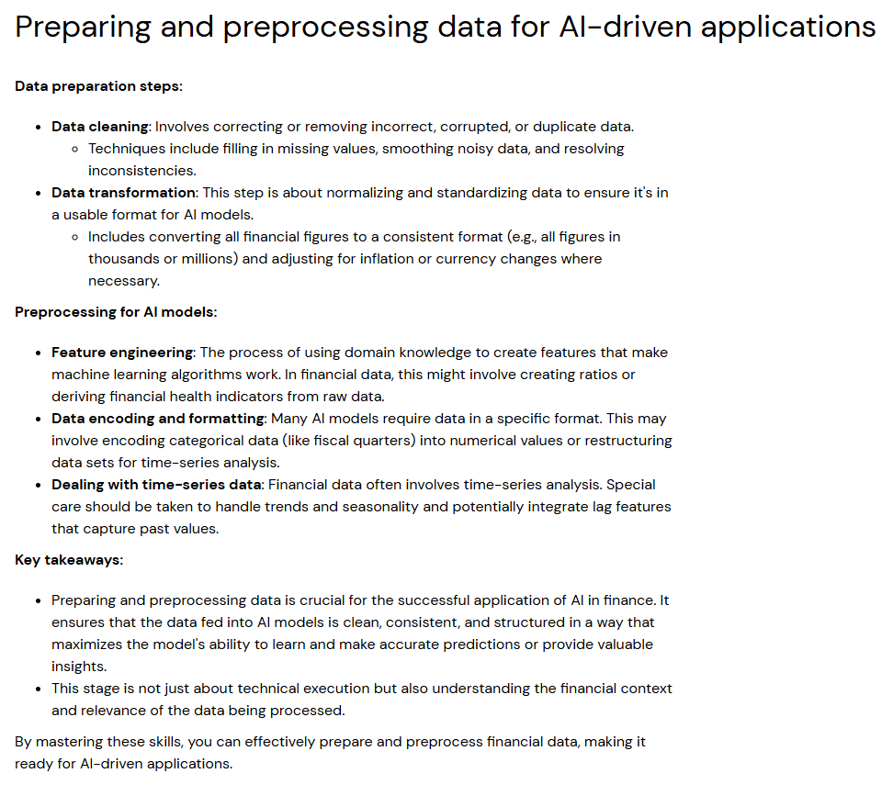

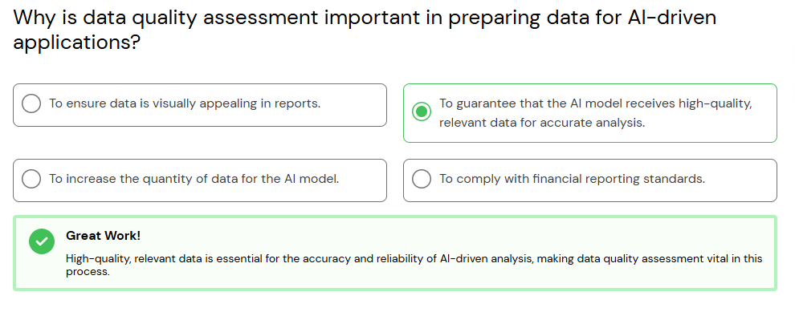

Task instructions
Your task is to manually extract key financial data for the last three fiscal years from the 10-K filings of Microsoft, Tesla, and Apple. Following the data collection, you will use Python to analyze this data, focusing on trends and insights that could inform the development of an AI-powered financial chatbot.
Step 1: Data extraction
Navigate to the SEC's EDGAR database:
- Microsoft
- Tesla
- Apple
Manual extraction:
- For each company, find the 10-K filings for the last three fiscal years.
- Extract the following financial figures: Total Revenue, Net Income, Total Assets, Total Liabilities, and Cash Flow from Operating Activities.
Organize Your Data:
- Compile the extracted data into an Excel spreadsheet for easy reference during your Python analysis.
Step 2: Preparing your Jupyter Notebook environment
Install Jupyter (if not already installed):
- Install Jupyter using pip if you haven't already:
pip install notebook
- Launch Jupyter Notebook:
jupyter notebook
- This command should open Jupyter in your web browser.
Create a new notebook:
- In the Jupyter interface, create a new notebook for your analysis.
Step 3: Python analysis in Jupyter
Import pandas:
- At the beginning of your notebook, import the pandas library to work with your data.
import pandas as pd
Load your data:
- Convert your Excel file to a CSV file for easier handling, then load it into a DataFrame.
df = pd.read_csv('path_to_your_csv_file.csv')
Analyzing trends with pandas:
- Use pandas to calculate year-over-year changes for each financial metric. You can do this by creating new columns in your DataFrame that represent the percentage change from one year to the next.
df['Revenue Growth (%)'] = df.groupby(['Company'])['Total Revenue'].pct_change() * 100
df['Net Income Growth (%)'] = df.groupby(['Company'])['Net Income'].pct_change() * 100
- Explore other aggregate functions or groupings to analyze the data across different dimensions (by company, over years, etc.).
Summarizing findings:
- Conclude your analysis by summarizing your findings directly in the notebook. Use markdown cells to add narrative explanations of your analysis, discussing the trends and changes in financial metrics you've identified.
Step 4: Documentation and submission
- Document your analysis: Use the markdown feature in Jupyter Notebook to document your methodology, observations, and conclusions throughout the notebook.
- Export your notebook: Once your analysis is complete, export your Jupyter Notebook as a PDF or HTML file for submission.
  - You can do this from the "File" menu in Jupyter, selecting "Download as" and then choosing your preferred format.
This approach allows you to focus on the core analytical aspects using pandas within a Jupyter Notebook, providing a clear, documented narrative of your financial analysis process. By the end of this task, you'll have a comprehensive understanding of how to analyze financial data programmatically, a valuable skill set for data-driven decision-making.

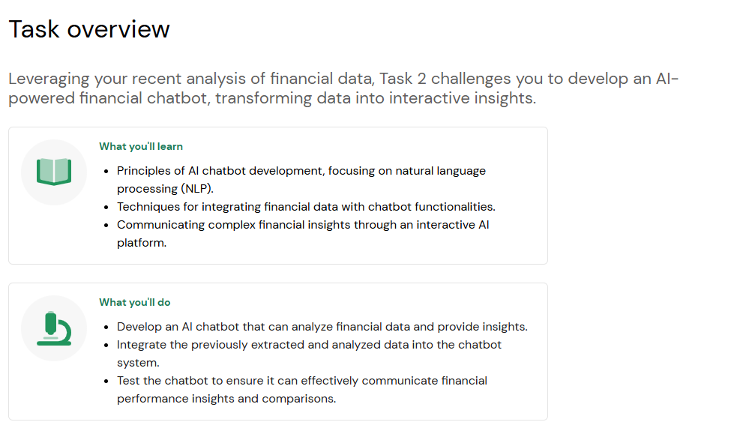

Principles of AI chatbot development
Before you begin, let's ground this task in some necessary understanding.
As we delve into AI chatbot development, it's crucial to grasp the foundational principles that make chatbots effective communicators and problem solvers. At its core, a chatbot is designed to simulate a conversation with human users. For our financial chatbot, this means that the AI should understand and respond to queries about financial data in a way that feels natural and helpful.
Rule-based logic: Start by implementing rule-based responses. This means your chatbot will use predetermined responses to specific queries. Think of it as a sophisticated "if-then" logic: if the user asks "X," then the chatbot responds with "Y." This approach is ideal for handling frequently asked questions about financial data.
State management: Even in a simple chatbot, managing the conversation's state is important. This involves remembering the context of the conversation or the user's previous queries to make responses more relevant and personalized.
Error handling: Prepare your chatbot to handle unrecognized queries gracefully. It should inform users when it doesn't understand a question and guide them towards queries that it can respond to.

Techniques for integrating financial data with chatbot functionalities
Integrating financial data into your chatbot is about making static data dynamic and interactive. The aim is to transform your previously analyzed financial data into insightful responses that the chatbot can provide when prompted by user queries.
Data structuring: Before integrating, ensure your financial data is structured in a way that allows your chatbot to access and interpret it easily. Using formats such as JSON or CSV can be helpful, as you can map data points to specific queries.
Retrieval methods: Implement simple retrieval methods that allow your chatbot to fetch the right piece of data based on the user's query. For instance, if a user asks about a company's net income, your chatbot should know how to find and present that specific data point.
Predefined data points: Since we're focusing on predefined queries, associate each query with specific data points in your data set. This direct mapping simplifies the process of fetching and presenting data in response to user inputs.

Communicating complex financial insights
The ultimate goal of your chatbot is to communicate complex financial insights in a way that's accessible and engaging. This involves presenting data in a manner that's informative and easy to understand.
Simplification and summarization: Work on simplifying and summarizing financial insights. Use clear, jargon-free language to explain financial concepts or data points. Remember, the user might not have a financial background.
Interactive dialogue design: Design your chatbot's dialogue to be interactive. Encourage users to explore different queries by suggesting related topics or asking follow-up questions. This can improve user engagement and make the interaction more informative.
Visual aids: While our focus is on text-based interaction, consider describing how data visualization aids such as charts or graphs could be referenced or described by the chatbot to aid in understanding complex data.
By understanding these principles and techniques, you're well on your way to creating a chatbot that communicates in an engaging and user-friendly manner and serves as a bridge between users and financial data. Remember, the key to a successful chatbot is its ability to communicate its findings to enhance user understanding and decision-making.

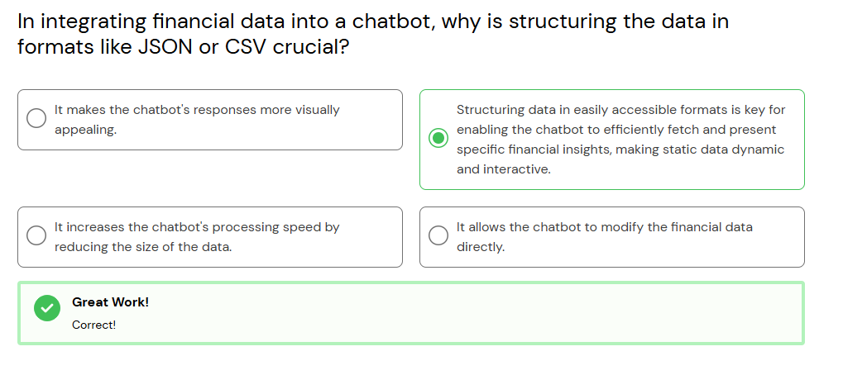

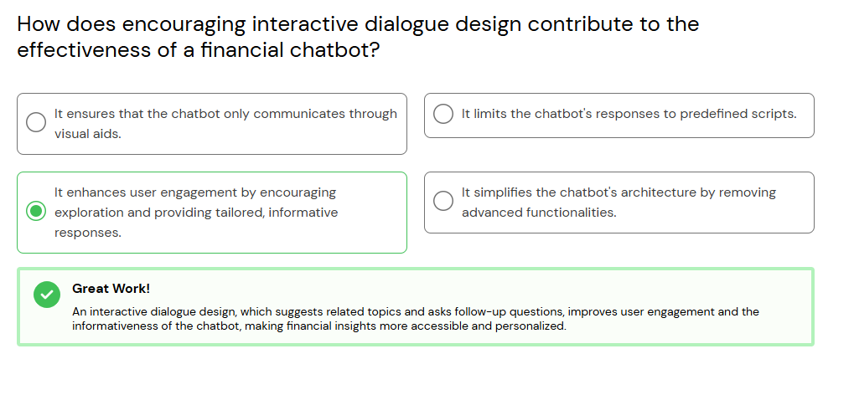

Ready to develop

Your primary focus will be on implementing rule-based logic, a foundational aspect that ensures the
- chatbot can respond accurately to a set of predefined financial queries.
- This task is essential for giving the chatbot its
- initial "understanding" of user inquiries and its ability to provide immediate, reliable information.

Meanwhile, other team members will tackle different facets of the chatbot's development:
- Natural language processing (NLP) experts: Colleagues specializing in NLP are working to refine the chatbot's ability to parse and understand the nuances of human language, enabling it to interact more naturally with users.

To parse simply means to take something complex and break/split it down into smaller, understandable pieces so you can work with it.
In programming and data work, it usually means:
Meaning of “parse”
- Read raw data (text, JSON, HTML, CSV, logs, etc.)
- Break it into structured parts
- Extract the information you need

Simple examples
Parsing a string

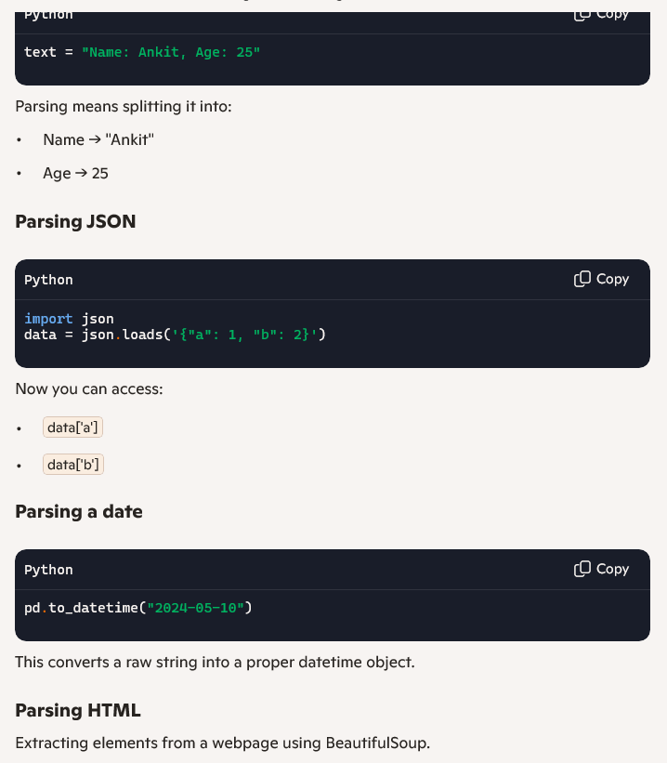

- Machine learning engineers: This segment of the team is dedicated to incorporating machine learning algorithms that allow the:
** chatbot to learn from interactions, improve its responses over time, and handle more complex queries beyond the rule-based scope. **
- Data integration specialists: These are team members focused on the
- seamless integration of financial data, ensuring
- the chatbot has real-time access to
- accurate and comprehensive financial information.
- User experience (UX) designers: UX designers are ensuring that interactions with the chatbot are intuitive and user-friendly, designing interfaces that make financial insights accessible to all users, regardless of their financial expertise.

Your role in developing the rule-based logic is a critical piece of a much larger puzzle. By focusing on this aspect, you're laying the groundwork for the chatbot's functionality and enabling further developments in AI, machine learning, and user interaction.
As you progress, remember that collaboration and communication with your team are key. Your work on rule-based logic sets the stage for the more sophisticated functionalities that your teammates are building, moving us closer to revolutionizing financial analysis for GFC.

Chatbot prototype:

Building a fully functional AI chatbot is a complex process involving
- advanced programming and deep learning techniques.

This streamlined version will introduce you to the basics of chatbot development, focusing on creating a prototype that responds to predefined financial queries.
- offering a glimpse into their potential without the need for extensive development time or advanced technical skills.

Step 1: Preparation
- Review the analyzed data: Quickly review the financial data you analyzed in Task 1 to refresh your memory on what information is available.
- Set up your environment: Ensure Python and essential libraries (like pandas for data handling and Flask for a simple web application, if applicable) are installed.
Step 2: Chatbot design and data preparation
- Define predefined queries: Select 3 to 5 common financial queries (e.g., "What is the total revenue?", "How has net income changed over the last year?").
- Prepare responses: Use the analyzed financial data to create canned responses for these queries. This step involves mapping each predefined query to a specific response based on your data analysis.
Step 3: Basic chatbot development
- Chatbot logic: Write a simple Python script that uses if-else statements to match user input (the predefined queries) to the responses you prepared. For a more interactive experience, consider using a basic Python library such as input() for command-line interaction or a simple Flask app for web-based interaction.
- def simple_chatbot(user_query):
- if user_query == "What is the total revenue?":
- return "The total revenue is [amount]."
- elif user_query == "How has net income changed over the last year?":
- return "The net income has [increased/decreased] by [amount] over the last year."
- # Add more conditions for other predefined queries
- else:
- return "Sorry, I can only provide information on predefined queries."

Step 4: Demonstration and documentation
- Test your chatbot: Spend a few minutes testing the chatbot with the predefined queries to ensure it responds correctly.
- Prepare a brief documentation: Write a short summary explaining how your chatbot works, the predefined queries it can respond to, and any limitations.
Once you've completed the streamlined chatbot task, it's time to compile and submit your work. Please package your Python script, any test results, and a brief documentation of your chatbot's functionality and limitations into a single zip file.

